Order No:153 of 2025
Dated: 11-12-2025
Subject: Physical verification and restoration of Physics & Chemistry Lab equipment/items at Government Polytechnic, Srinagar.
In order to ensure proper utilisation of available laboratory resources and to maintain functional laboratories in the department, the following officials are hereby deputed to immediately visit the Physics and Chemistry Laboratories of this Institution and carry out the following tasks:
- Mr. Ashaq Hussain Patloo, Assistant Foreman.
- Mr. Mohammad Waseem, Helper / Lab Technician
- Mr. Rafiq Darzi, Junior Lab Assistant
- Mr. Umer Ahmad, Electrician
Tasks assigned:
- Conduct thorough physical verification of all Physics and Chemistry laboratory equipment, instruments, apparatus, glassware, chemicals, charts, models, etc.
- Identify items that are repairable/functional with minor repairs or maintenance.
- Make all possible efforts to restore such items to working condition (including electrical connections, minor repairs, cleaning, calibration, etc.).
- Prepare a detailed list of items that are beyond repair or obsolete and recommend them for condemnation/disposal as scrap as per rules.
- Submit a comprehensive report along with inventory (functional + non-functional) to the undersigned within 03 (Three) days positively.
The team will be headed by Mr. Ashaq Hussain Patloo, Assistant foreman. Team shall coordinate with the Incharge (Physics/Chemistry) Lab and complete the assignment on a top-priority basis.
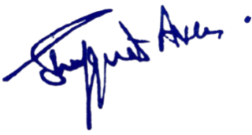
No: KGP/Estt/2025/1794
Dated:11-12-2025

Dr. Shafquat Ara
Principal
Kashmir Govt.Polytechnic College Srinagar

